# Milestone #4 - Thirsty Tracker

**Revised List of Features**

1. User registration (Save profiles, login, save favorites, have a history) Underage Option
   1. Have users create a profile that will be saved into a database
   2. Be able to login using a username and password
   3. History
   4. Have a favorites restaurant list that is saved to the user profile
2. Filter restaurants by various aspects such as:
   1. Price
   2. Type of alcohol served
   3. Hours
   4. Location
   5. Favorites
3. Recommended
   1. A tool that is used to to sort your preferences on what you’re looking for. If you can’t decide on an option then a happy hour place will be recommended for you based on previous visits to the establishment as well as places you haven’t visited before.
   2. Search - a search bar giving ability to search for restaurants by name or by keywords relating to the restaurant and its food/drinks
4. Ratings/Reviews
   1. For now, just put the stars you would give the place. Maybe later implement actual reviews from users.
   2. Attach restaurant’s average score to the restaurant profile. Have users’ own score tied to their individual profile.
5. Inputted database of restaurants (Stay in Boulder proper for now)

# Architecture Diagram

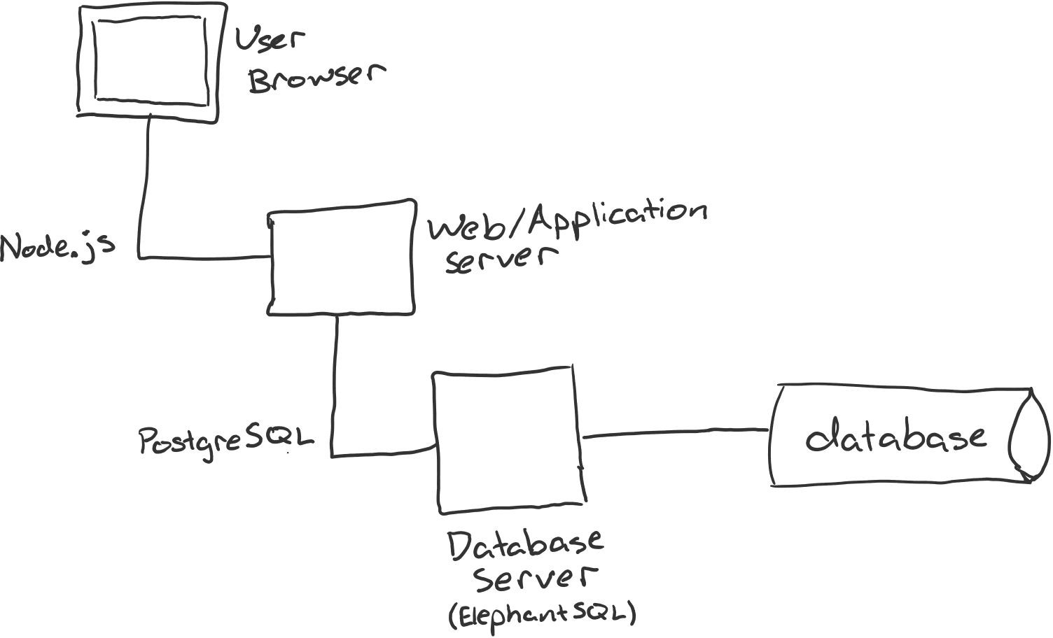

**Front End Design**/**Web Service Design**

We are using ElephantSQL, a service that hosts databases on the cloud. We did not, however, have to use any APIs.

# Back End Design

